Project Design Phase-II
Technology Stack (Architecture & Stack)
Structural Components Matrix & Modern Application Blueprint
Date | 12July 2026
Team ID
Project Name | Darshan ease
Maximum Marks | 4 Marks

Technical Architecture Diagram
The deliverable includes a modern 3-Tier structural architectural system implementation mapped out below. It captures the data serialization context rules governing asynchronous client interactions through protected gateway routes.
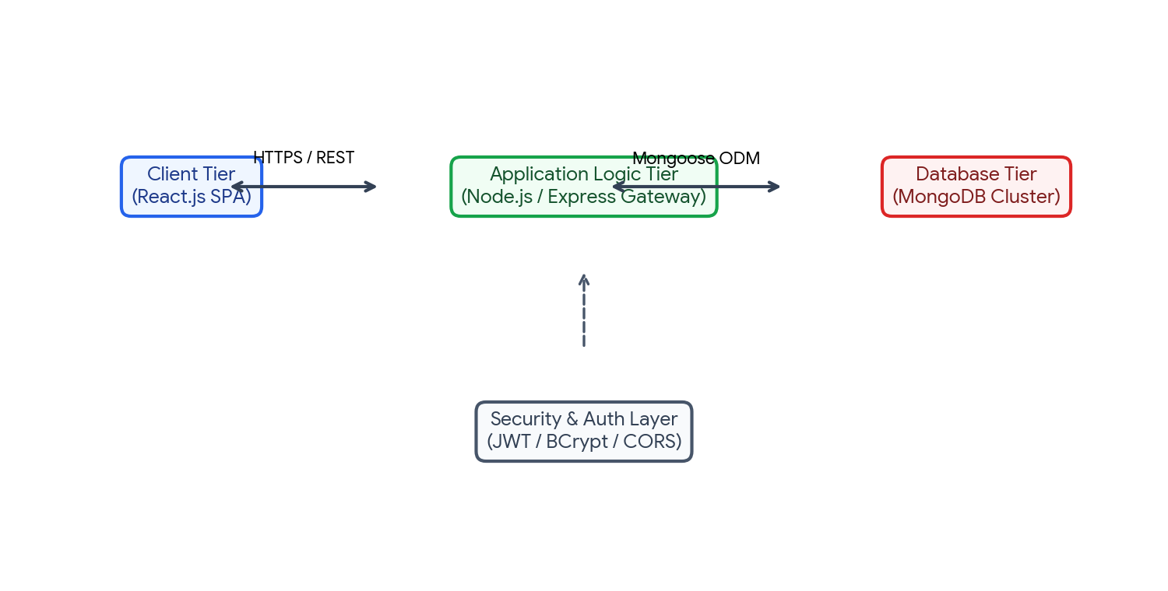
Figure 3.1: Complete 3-Tier Core Infrastructure Flowchart for my-mern-project.
Table-1: Components & Technologies Mapping Matrix
S.No | Component | Description / Functionality | Technology Used
1 | User Interface | Renders responsive interactive Client Viewports and tracks system application state. | React.js / HTML5 / CSS3 / Tailwind
2 | Application Logic-1 | Manages runtime routing logic rules and sets context validation parameters. | Node.js (LTS Version Runtime Environment)
3 | Application Logic-2 | Provides middle-tier endpoint endpoints controller routing pipelines. | Express.js Framework Core Layer
4 | Application Logic-3 | Establishes institutional abstraction interface bindings to relational BSON pipelines. | Mongoose ODM Object Modeling
5 | Database Layer | Controls persistent non-relational collection serialization structures efficiently. | MongoDB Engine Local Database
6 | Cloud Database | Provides geo-distributed high resiliency transaction instances data clustering. | MongoDB Atlas Cloud Cluster
7 | File Storage | Manages localized logs directories, environment variables config collections. | Local POSIX Server Filesystem
8 | External API-1 | Ensures secure verification checks and provides dynamic social lookup models. | Google OAuth2 Validation Framework
9 | External API-2 | Validates cross-origin resources payload transmission permissions strictly. | CORS Routing Controls Layer
10 | Infrastructure Context | Handles application execution loops, local reverse-proxy configuration bindings. | Local Node Processes / Cloud Engine

Table-2: System Application Characteristics Criteria
S.No | Characteristics | System Design Description Criteria | Technology / Frameworks
1 | Open-Source Frameworks | Ensures high velocity open development loops utilizing stable standardized node package systems. | React Core Engine, Express Framework, Node Environment
2 | Security Implementations | Implements robust encryption strategies for user credentials payload protection. | JSON Web Tokens (JWT), bcrypt Salt Hashing, Helmet protection
3 | Scalability Matrix | Decouples browser UI entirely from the service orchestration pipeline ensuring clean load splits. | 3-Tier Decoupled Client-Server MERN Architecture
4 | High Availability | Allows zero-downtime rolling upgrades and supports horizontal replicas out-of-the-box. | Distributed Database Nodes Cluster (MongoDB Atlas Engine)
5 | Performance Tuning | Optimized data parsing strategies using highly responsive runtime event configurations. | Asynchronous Non-blocking I/O Loops Engine

Academic & Technical References
- The C4 Model architectural system design strategy (https://c4model.com/)
- IBM Cloud Architecture Reference Frameworks (https://www.ibm.com/cloud/architecture)
- AWS Architecture Framework blueprints guidelines (https://aws.amazon.com/architecture)
- Modern decoupled application structure standards mapping methods.

